1. Create a lookup table like the one shown in the diagram below and give it a sensible range name:

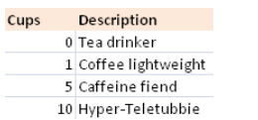

**Answer:**



* 1. Create a Vlookup function to describe each Teletubby

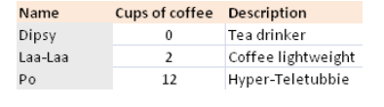

**Answer:**



* 1. Try nesting your lookup function inside an If function so that you see an appropriate message if the cups of coffee is less than zero.

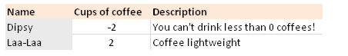

**Answer:**

